
Pre-Board Examination, 2079
Full Marks : 80
Pass Marks : 32
Time : 3 Hrs.
B.Sc.CSIT / 1st Semester / Digital Logic
Candidates are required to answer all the questions in their own words as far as practicable. Figures in brackets indicate full marks.

Long Questions:
Attempt any two questions: (2 X 10 = 20)
1. What are the major differences between Programmable Logic Array (PLA) and Programmable Array Logic (PAL)? Implement the following two Boolean functions with a Programmable Logic Array (PLA):
F₁(A, B, C) = Σ (0, 1, 2, 4)
F₂(A, B, C) = Σ (0, 5, 6, 7)
2. Design a sequential circuit that follows the given state diagram using T Flip Flops.
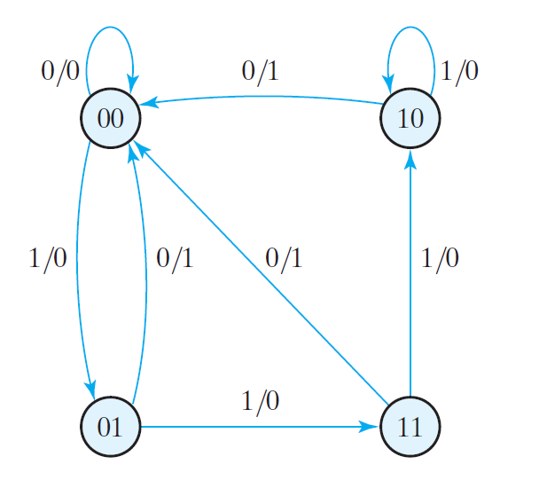
3. Draw a circuit diagram for a synchronous counter that follows a sequence of 9 states and returns to 0 after the count of 8 (i.e. Mod-9 Counter).

Short Questions:
Attempt any eight questions: (8 X 5 = 40)
4. What is 2’s complement? Subtract (1101.10)₂ from (1010.01)₂ using 2’s complement method.
5. Find the complements of the following functions:
a. F₁ = x’ y’ z + x’ y z’
b. F₂ = (x + y + z’)(x y’ z + y z’)
6. What do you mean by K-Map? Implement the following boolean function using NOR gates only.
F(x, y, z) = Σ(0, 1, 5, 8, 9, 12)
7. Obtain the simplified Boolean expressions for output F and G in terms of the input variables in the given circuit.
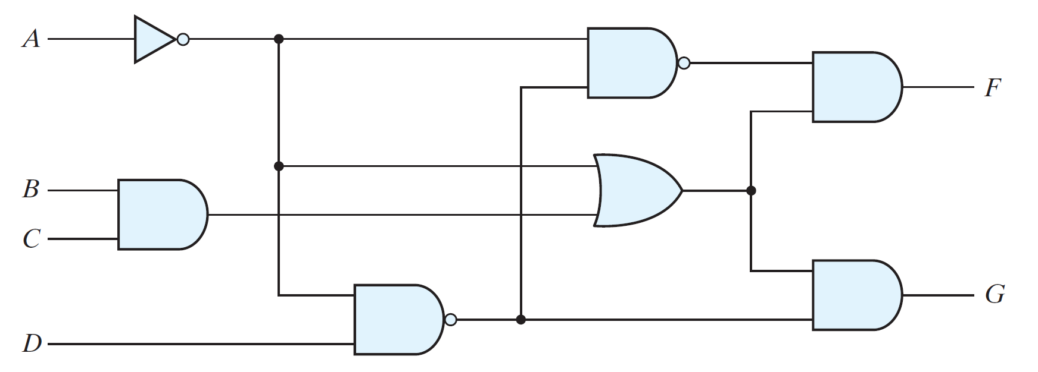

8. What is Priority Encoder? Draw the circuit diagram for Three-to-Eight line Decoder.
9. Implement the following function using 4X1 Multiplexer. Draw the corresponding circuit diagram.
F (A, B, C) = Σ(0, 3, 6, 7)
10. Write down the Characteristic Equations and Excitation Tables of the D Flip-Flop, T Flip-Flop and JK Flip-Flop.
11. For the given state diagram,
Present State | Next State |  | Output
 | x = 0 | x = 1 | x = 0 | x = 1
a | f | b | 0 | 0
b | d | c | 0 | 0
c | f | e | 0 | 0
d | g | a | 1 | 0
e | d | c | 0 | 0
f | f | b | 1 | 1
g | g | h | 0 | 1
h | g | a | 1 | 0

(a) Tabulate the reduced state table.
(b) Draw the state diagram corresponding to the reduced state table.
12. Draw the circuit diagram for the Three Stage (or, Mod-6) Johnson’s counter. Mention the Count Sequence for the counter and the corresponding decoding AND terms.
13. Write Short notes on (any two):
a) Parity Generator and Checker
b) JK Flip-Flop
c) Binary Cell of RAM

